**AS91906 – Evidence of ongoing testing**

**Date: 9/08/19**

What I tested was to make sure the mann_theatre was displaying on the GUI inside the listbox.

**Comment:** Initially only displayed two movies in the in the listbox to check that the only two movies that had been imported was printing.

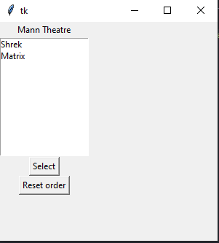

**Date: 9/08/19**

What I tested was the theatre if the induvial movies were displaying in Academy.

**Comment:** I purposely only displayed one movie in the academy theatre to test if the were propaly calling the movie

**Evidence:**

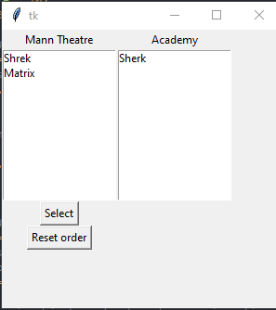

**Date: 9/08/19**

**What I tested:** I tested all the movies separately by setting them all up in all the list boxes to display in the GUI.

**Comment:** I did this on purpose because I needed to check if the list box is calling from the correct theatre.

**Evidence:**

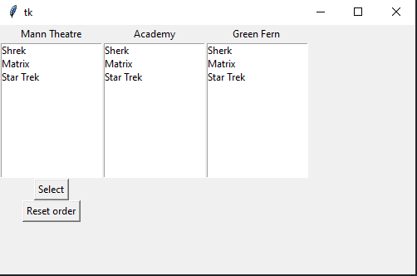

**Date: 9/08/19**

What I tested was if the Mann Theatre was calling the correct movies to the right list box so I eited the name of the movie which I only changed one movie.

**Comment:** I did this on purpose because I have set up the movie function separately because it will generate the movies correctly and cleanly.

**Evidence:**

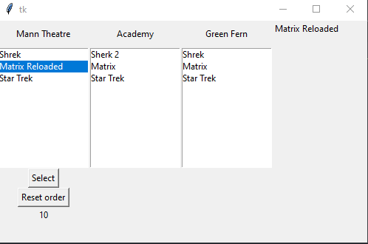

**Date: 12/08/19**

**What I tested is the price and seats of the man theatre to display correctly by only testing in one list box.**

**Comment:** Initially I set this up to check if the tickets/seats and price was being called from the correct function.

**Evidence:**

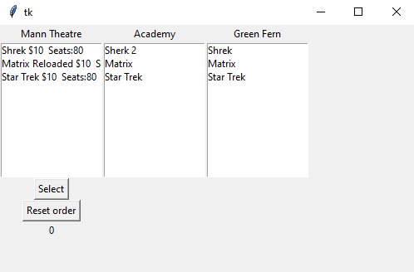

**Date: 14/08/19**

What I tested was all the list box and prices was being called into all of them. I also moved the moved the “Reset Order” to the corner to make it more user friendly. The quantity box was also set up to so the user can choose how many tickets they need.

**Comment:** Initially did this so it made it clear if all the functions were working in the GUI and to play around to work out where positions of the buttons need to be.

**Evidence:**

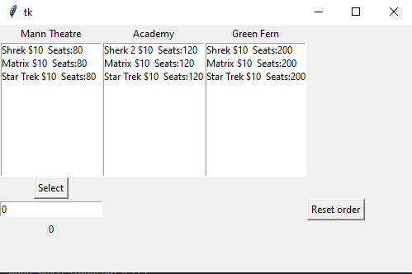

**Date: 14/08/19**

What I tested is to check if the select button was correctly pushed to the side next to the reset order and where the quantity box is in the right the position.

**Comment:** Initially did this because I needed to see how the layout is looking and see what need to be changed which was the quantity box and price.

**Evidence:**

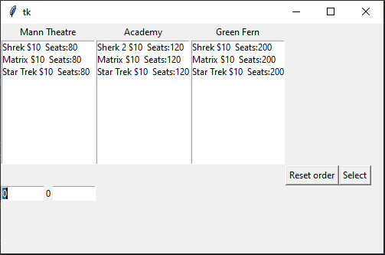

**Date: 14/08/19**

What I tested was the formatting of where the cost results sit and the movie summary.

**Comment:** Initially did this to make it more user-friendly for the users to buy tickets and which theatres they are choosing. Plus, to make it easier for those who want more than one ticket.

**Evidence:**

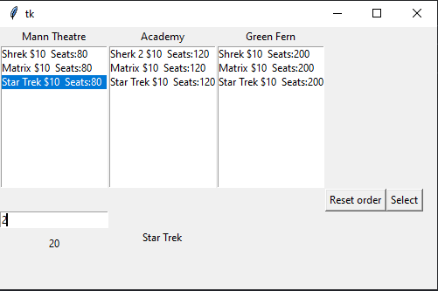

.

**Date: 15/08/19**

**What I tested:** e.g. Testing to make sure that all enrolled students were displayed in the listbox

**Comment:** e.g. Initially all students were displayed so I had to add an if statement to check whether a student was enrolled before displaying their name.

**Evidence:** 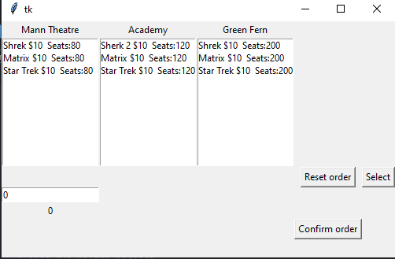

**Date: 16/08/19**

What I tested was if the total cost was printing with the correct integer. Star Trek $10 * 4 = 40.

**Comment:** This was successful due to the function working probably by multiplying the quantity and price in three different theatres.

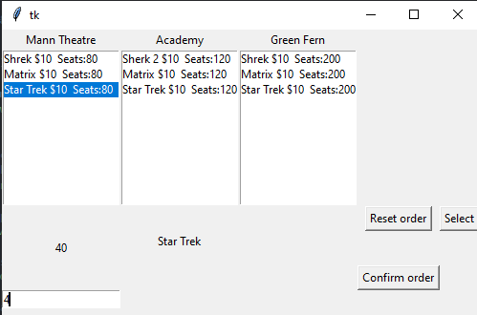

**Date: 16/08/19**

What I tested was the movies seats/comments to subtract to display 200-4 = 196. This was to check if the user could see the remaining seats

**Comment:** Initially I had all movies displayed but then it multiplied itself so I added a statement that would allow the movies, price and seats to be deleted then updated with the current ones.

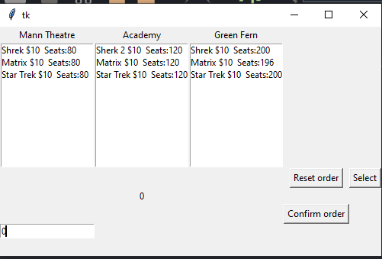

Jack: 16/08/19

Would use buttons rather than typed input field

Simple and easy to use.

Jacques: 16/08/19

Program is clear with little chance of making a mistake. Would however, subtract the number of seats from each film once order is placed.

Dakota: 16/08/19

There isn’t much UI for this program, very hard to use, as in there aren’t any headings or titles which makes the program hardly usable. Because of this I would say the program is far from complete, as even with instructions the program gave no feedback as to if my movie order was either complete, or unable to be booked. The current UI, or lack, therefore, is very hard to read and would benefit having larger buttons and text. Placing different elements in order of use would help to lead a user through the program, as I have already stated, there is no clear directions to follow to properly use the program.